DSA 0601 - Data handling and visualization
Set 16 - Customer Demographics Analysis

Name : B.Jahnavi
Reg.no:192325043

- Bar Chart to Visualize Customer Age Distribution
Code:

library(ggplot2)

# Create dataset
customers <- data.frame(
Customer_ID = c(1, 2, 3),
Age = c(28, 35, 42),
Gender = c("Female", "Male", "Female"),
Income = c(50000, 60000, 75000)
)

# Create bar chart
ggplot(customers, aes(x = factor(Age))) +
geom_bar() +
labs(
title = "Distribution of Customer Ages",
x = "Customer Age (Years)",
y = "Number of Customers"
) +
theme_minimal()

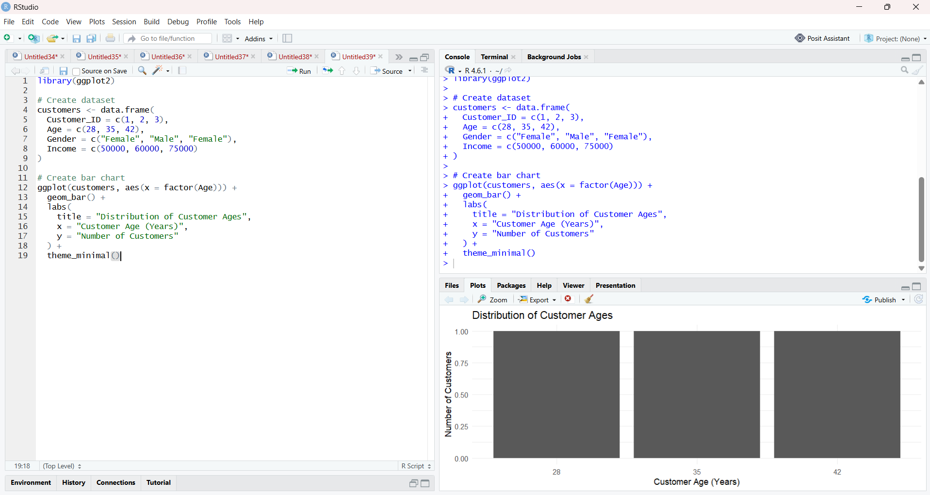

2. Pie Chart to Represent Gender Distribution
Code:

library(ggplot2)

customers <- data.frame(
Customer_ID = c(1, 2, 3),
Age = c(28, 35, 42),
Gender = c("Female", "Male", "Female"),
Income = c(50000, 60000, 75000)
)

gender_count <- as.data.frame(table(customers$Gender))
colnames(gender_count) <- c("Gender", "Count")

ggplot(gender_count, aes(x = "", y = Count, fill = Gender)) +
geom_bar(stat = "identity", width = 1) +
coord_polar("y") +
geom_text(
aes(label = paste0(Count, " (", round(Count / sum(Count) * 100), "%)")),
position = position_stack(vjust = 0.5)
) +
labs(
title = "Customer Distribution by Gender",
fill = "Gender"
) +
theme_void()

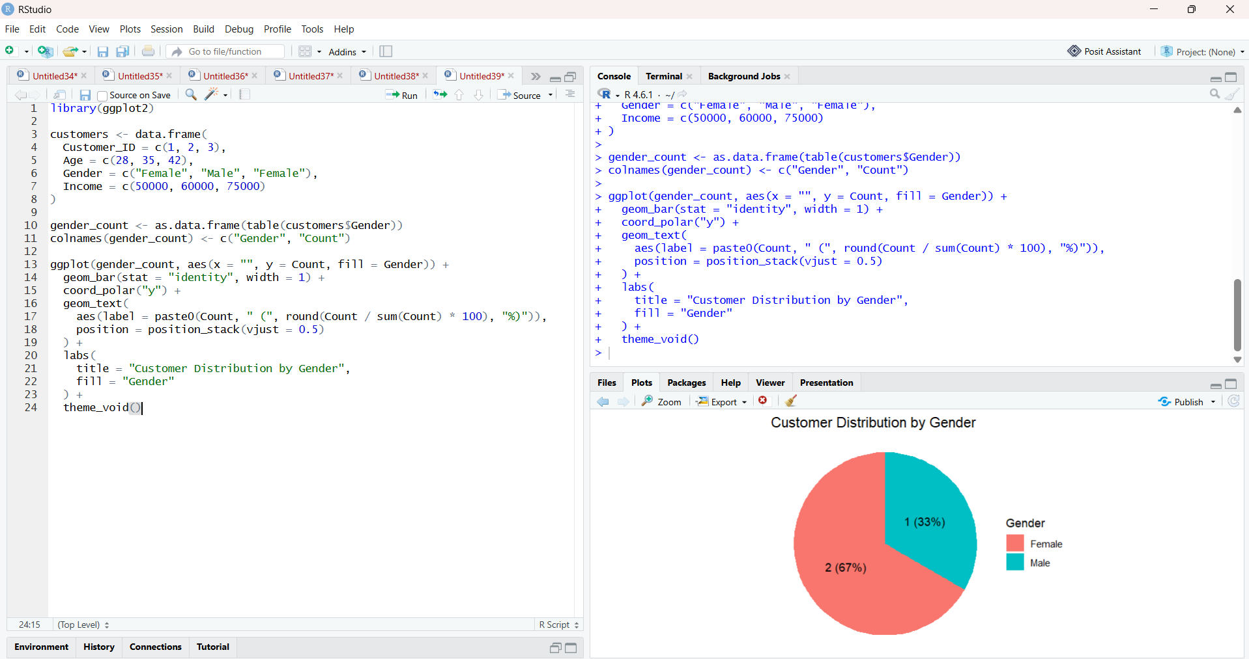

3. Table of Customer Demographics
Code:

customers <- data.frame(
Customer_ID = c(1, 2, 3),
Age = c(28, 35, 42),
Gender = c("Female", "Male", "Female"),
Income = c(50000, 60000, 75000)
)

print(customers)

# Optional formatted table
library(knitr)

kable(
customers,
caption = "Customer Demographic Information",
col.names = c("Customer ID", "Age", "Gender", "Income ($)")
)

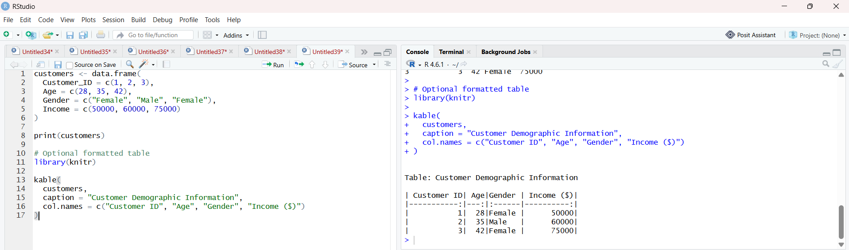

4. Prepare Data for Tableau Dashboard
Code :

customers <- data.frame(
Customer_ID = c(1, 2, 3),
Age = c(28, 35, 42),
Gender = c("Female", "Male", "Female"),
Income = c(50000, 60000, 75000)
)

write.csv(customers, "customer_demographics.csv", row.names = FALSE)

print("CSV file created successfully.")

